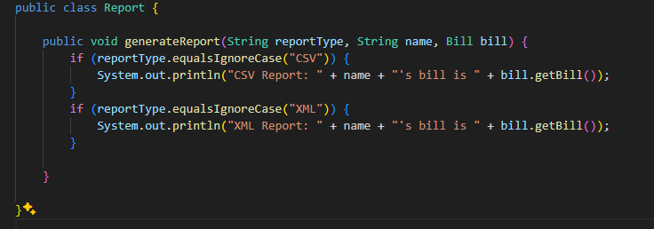
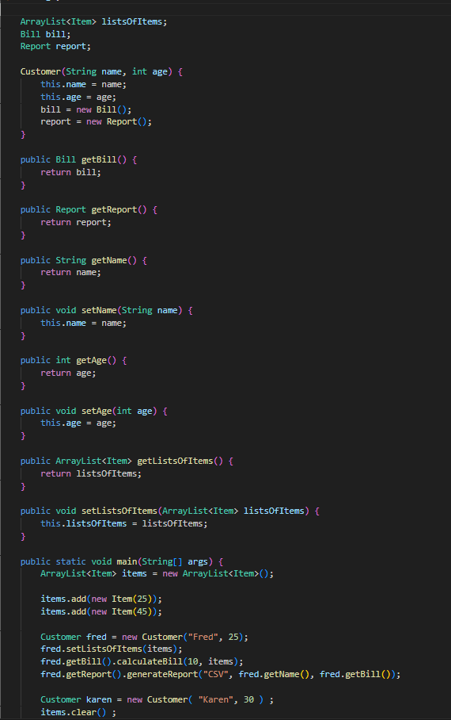
1.
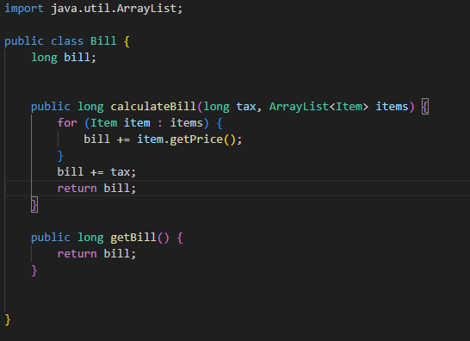

2. The board violates SRP because it handles loading all the configuration files and parsing the data from the files. The board also violates SRP because the targets for each cell are calculated in the board class. Another way is that the board class handles all functionality of the game from playerTurns, movement, suggestion, and accusations. The board also checks the suggestions and compares them with the cards in the players’ hands. The board also dictates the win and lose conditions of the game. The board handles a lot of functionality, most of which could be separated into its own classes.

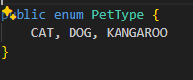
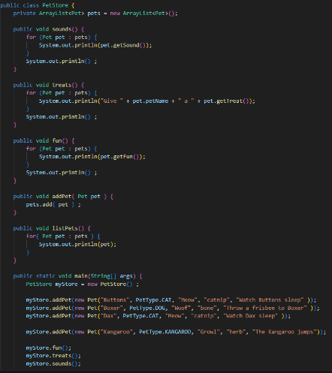
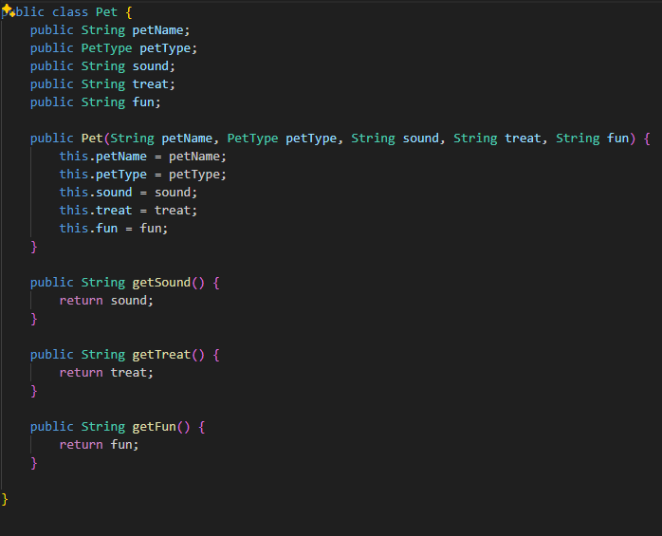
3.

4. The original code violated OCP because the functionality of each animal was in the PetStore class. If a new animal was added the pet functionality needed to be added to each of the functions in the PetStore class to display the animal. The new code does adhere to OCP because when a new animal is created it is provided with all the functionality of the animal. When the PetStore displays the animal functionality no code needs to be added.

5. This design violates ISP because the Ebook class has a variable and function that it does not need. That would be the "restock" and "minInStock". An eBook is a virtual book, so it does not need those. To fix this it would be better to have two child classes of type Book one be a PhsycialBook and the other Ebook. The way those child classes have the information that they only need.

6.
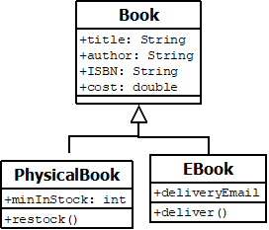

7. You do not need two child classes, as those classes hold no information. Instead, it would be better to have a sperate ENUM class that holds all the possible majors. The student could then have an instance variable that holds their major or an array list that holds multiples majors if they can have more than one.

